Lynne Lammers
EECS 448
Lab 2

2) Best Image: 1-step exposure [1,2,3,4], default tone map
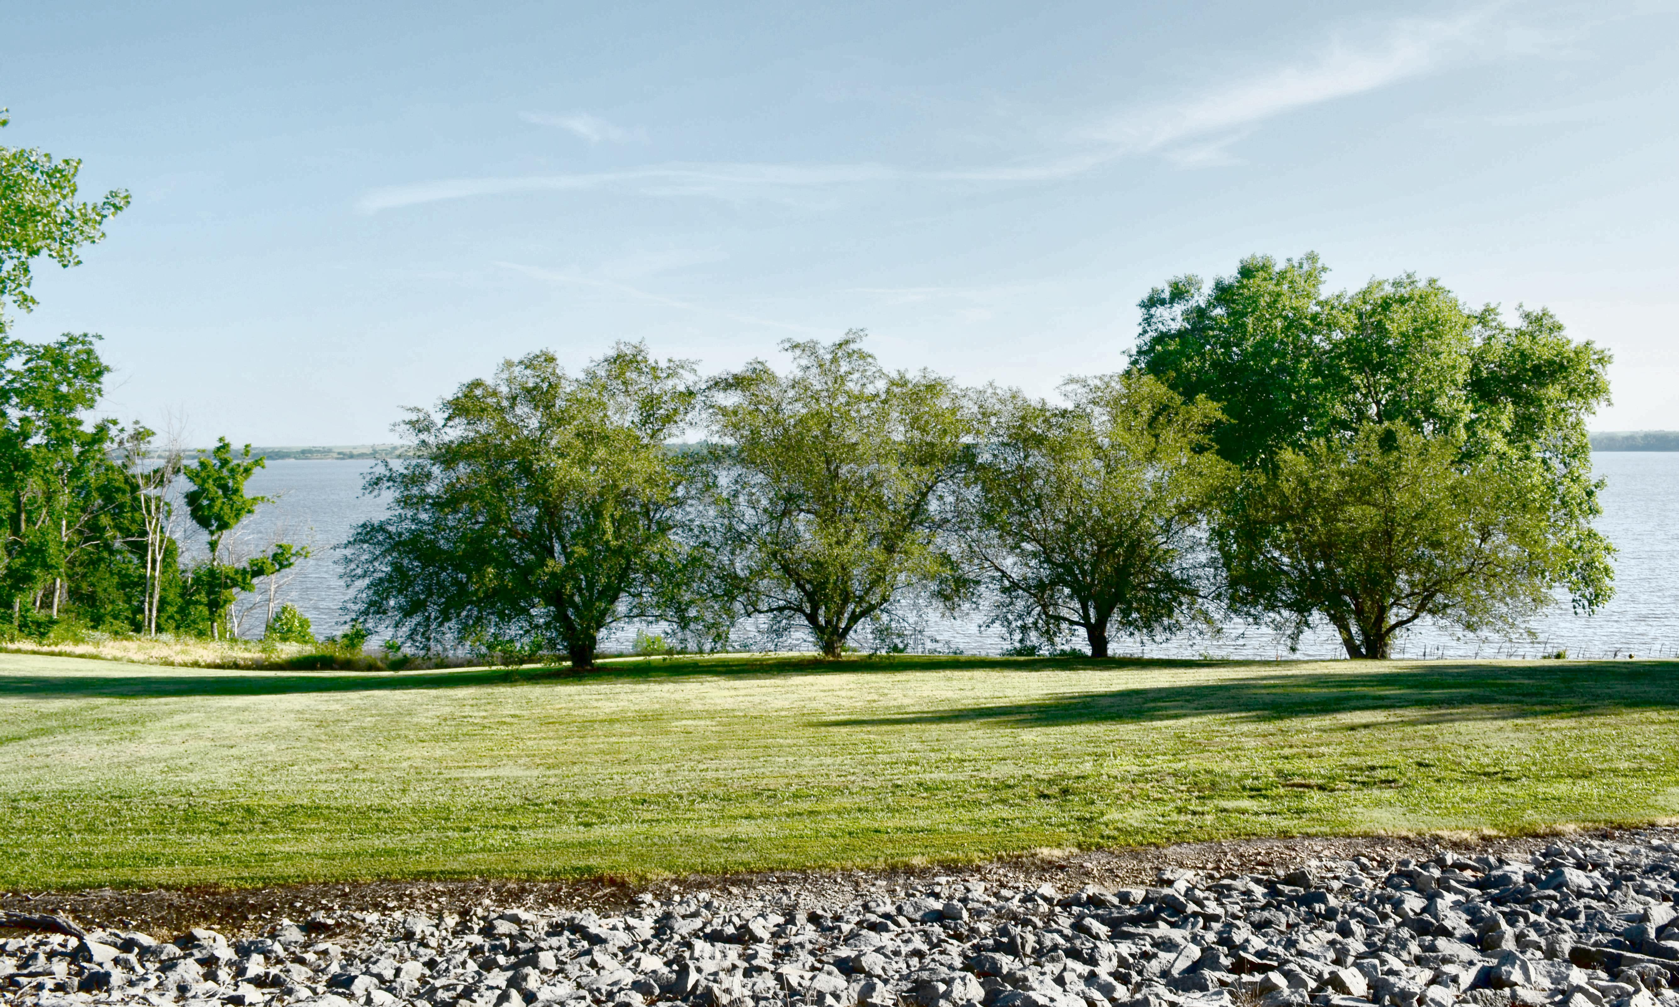

3) Best Image: Exposure [1,2,3,4], Lightness: [0.05, 1]
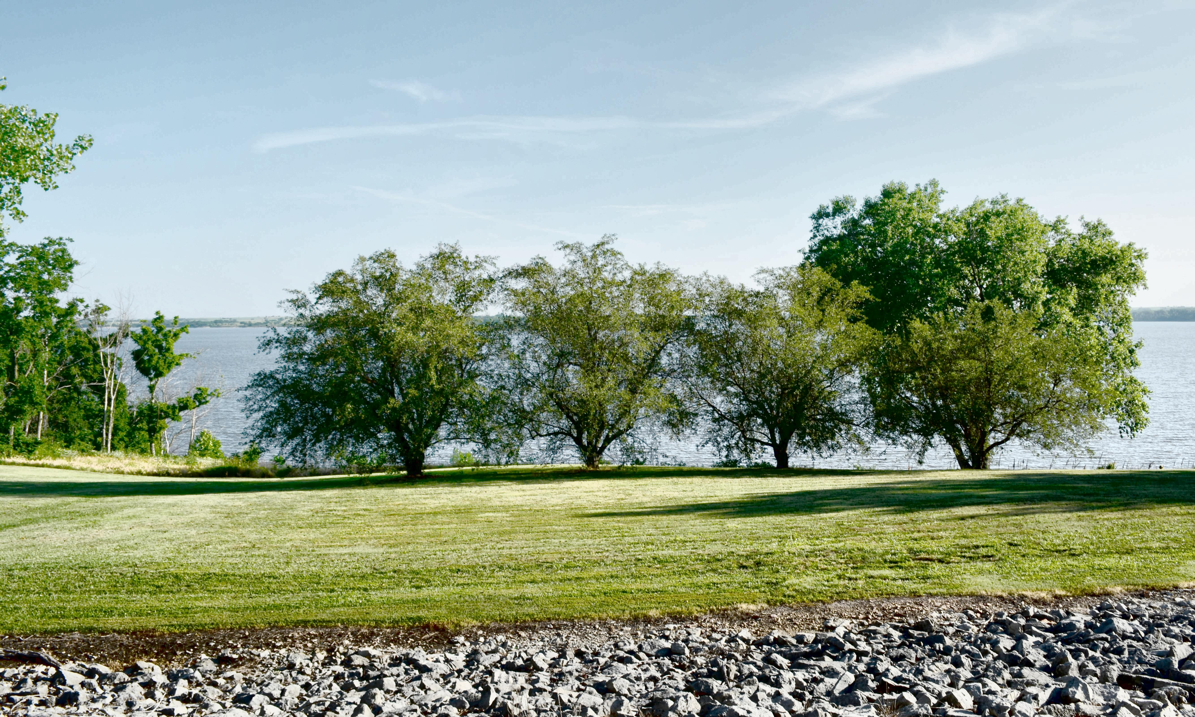
4) Best Image: Exposure [1,2,3,4], Lightness [0.05, 1], Saturation 1.35
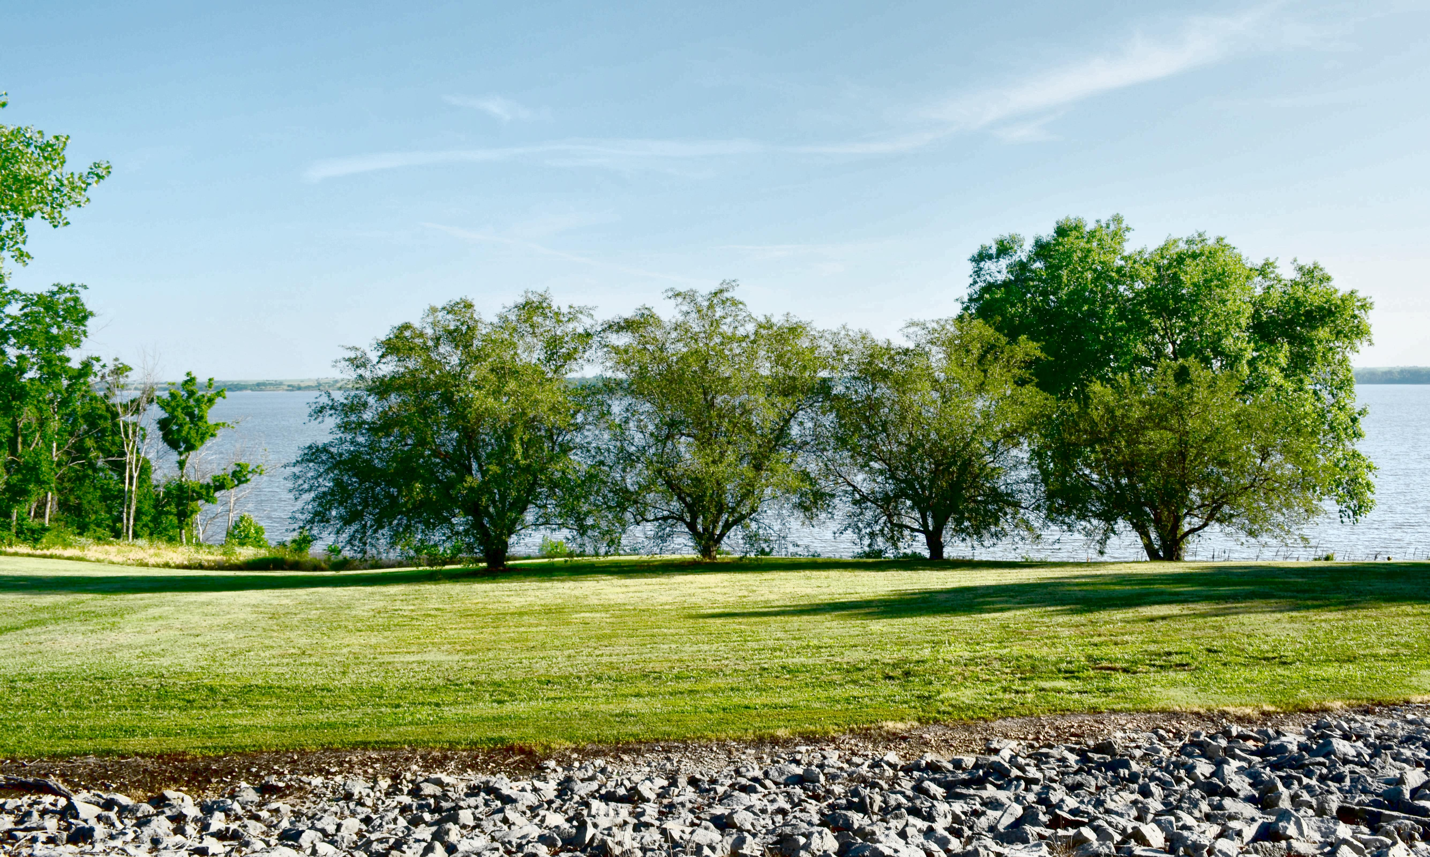

- Best Image: Exposure [1,2,3,4], Default Lightness, Saturation 1.375
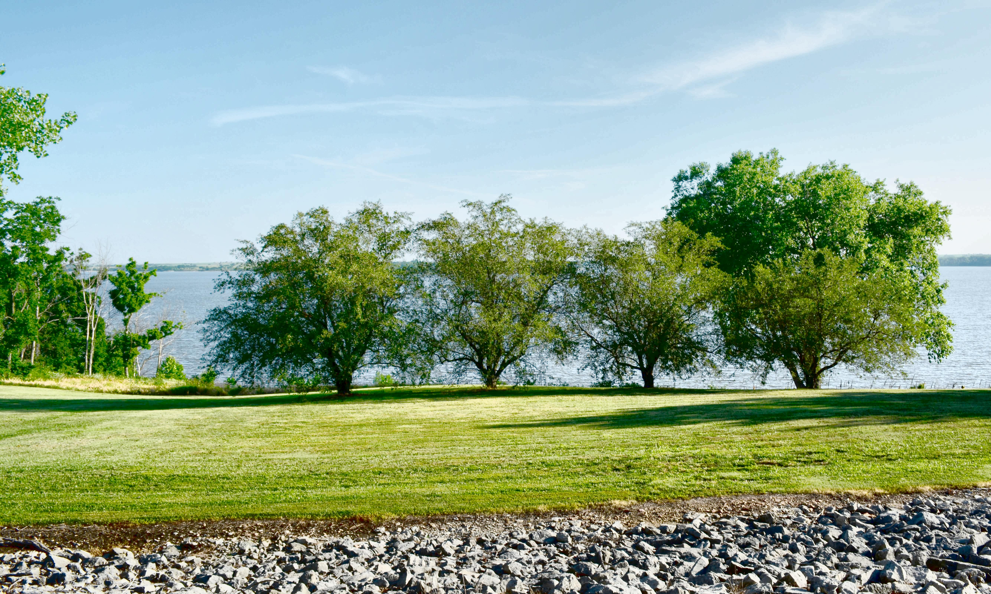
6) Best Image: Exposure[1,2,3,4], Default Lightness, Saturation 1.375, Num tiles [5,5]



